|  |  |  |  |  |
| --- | --- | --- | --- | --- |
| **Object Oriented**  **Programming**    **Lab**  **(2+1 Credit Hours)**    CSL-210 |  |  |  |  |
| OOP Project Report  Project Title: Recipe Finder  **Submitted by:**  Sara Tariq |
| **DEPARTMENT OF COMPUTER SCIENCE**  BAHRIA UNIVERSITY, KARACHI, PAKISTAN | | |

# ABSTRACT

This project is a desktop application that serves as a recipe finder tool for users. The application allows users to input the ingredients they have on hand and then generates a list of recipes that match those ingredients. The application is designed to be user-friendly and easy to navigate, making it accessible to a wide range of users. The recipe finder feature is the main focus of the application, but it also includes additional functionalities such as the ability for users to save their favorite recipes and search for recipes by specific dietary restrictions. The application also allows users to filter the results by course, cuisine, and difficulty level. The goal of this project is to provide a convenient and efficient tool for users to find and make recipes using the ingredients they have on hand.

**Table of Contents**

ABSTRACT 1

1. Introduction: 2

2. Problem Statement: 3

3. Scope of Project: 3

4. Aims and Objectives: 4

5. Methodology: 5

6. Tools/Technology: 6

6.1. Apache NetBeans IDE 12.5: 6

6.3. Microsoft Access: 8

7. Flowchart: 10

7.1. code:…………………………………………………………………………………………………………………………………………..11

8. Application UI: 11

8.1. Login Page: 11

8.2. Signup Page: 12

8.3. Forgot Password: 13

8.4. User Section: 16

8.5. User Dashboard: 16

8.6. Search Recipe: 17

8.7. View Recipe Details: 18

8.8. All Recipes: 19

8.9. Saved Recipes: 20

8.10. Edit Profile: 20

8.11. Change Password: 21

8.12. Admin Section: 22

8.13. Admin Dashboard: 22

8.14. Admin Profile: 24

8.15. Change Password: 24

8.16. Add Recipe: 25

8.17. Update Existing Recipe: 26

8.18. Updating user roles: 26

9. Conclusion 27

# 1. Introduction:

Introducing the Recipe Finder Desktop Application, a comprehensive and user-friendly tool for finding and organizing your favorite recipes. Built using the Java programming language and utilizing a Microsoft Access database, this application offers a seamless and efficient way to search for, save, and organize your go-to recipes.

With the Recipe Finder, you can easily search for recipes based on a variety of criteria, including ingredients, cooking time, and dietary restrictions. The application also allows you to save your favorite recipes for quick and easy access, as well as create custom categories for organizing them.

In addition, the Recipe Finder offers a variety of features to enhance your cooking experience. You can view detailed recipe instructions. The application also allows you to make notes and modifications to your saved recipes, making it easy to tailor them to your own preferences.

Whether you're a novice cook or a seasoned pro, the Recipe Finder Desktop Application is the perfect tool for finding and organizing your favorite recipes. With its user-friendly interface and powerful search capabilities, it's sure to become your go-to tool for meal planning and recipe inspiration.

# 2. Problem Statement:

The problem that this recipe finder project aims to address is the difficulty that users often face in finding recipes that match the ingredients they have on hand. Many users struggle to come up with recipe ideas when they only have a limited selection of ingredients available, and often resort to searching through multiple cookbooks or online recipe databases to find something that matches their ingredient list. Additionally, users may also have trouble keeping track of the recipes they have tried and liked, making it difficult to replicate them in the future. This project aims to solve these problems by providing a convenient and efficient tool for users to find and make recipes using the ingredients they have on hand, and also to save their favorite recipes for future use. The project is a desktop application that can be easily installed and used by anyone who is looking for recipe ideas based on the ingredients they have on hand.

# 3. Scope of Project:

The scope of this recipe finder project is to develop a desktop application that allows users to find recipes based on the ingredients they have on hand. The application will be developed using the Java programming language and will utilize a Microsoft Access database to store and retrieve recipe information. The following specific functionalities will be included in the scope of this project:

* User registration and login: Users will be able to create an account and log in to the application to access recipe information.
* Ingredient search: Users will be able to input the ingredients they have available and receive a list of matching recipes.
* Recipe database management: Admin users will have the ability to add, edit, and delete recipes from the database.
* User interface design: The application will have a user-friendly interface that is easy to navigate and understand.
* Recipe details: Users will be able to view detailed information about each recipe, including ingredients, preparation instructions, and nutritional information.
* Search functionality: Users will be able to search for recipes by keyword and ingredient.
* Security: The application will be designed to protect user information and recipe data from unauthorized access. We have used SHA-256 to encrypt users’ passwords.

# 4. Aims and Objectives:

The aims and objectives of the Recipe Finder project are as follows:

* To provide users with an easy-to-use and intuitive interface for finding recipes based on the ingredients they have on hand.
* To create a database of recipes that can be easily searched and filtered based on ingredients, cooking time, and other criteria.
* To enable users to save their favorite recipes and create shopping lists based on the ingredients needed for a particular recipe.
* To allow admin users to manage the recipe database, including adding, editing, and deleting recipes as needed.
* To develop a robust and scalable software application using the Java programming language and MS Access database.

# 5. Methodology:

The methodology used in the Recipe Finder project is as follows:

**Requirements gathering:**

The first step in the project was to gather and analyze the requirements of the software. This involved identifying the main features of the software and determining the specific functionality that would be required to meet the needs of the users.

**Database design:**

Once the requirements were understood, the next step was to design the database that would be used to store and manage the information related to the recipes. The Microsoft Access database was chosen for its user-friendly interface and its ability to handle a large number of records.

**Java programming:**

The Java programming language was used to develop the software application. This involved creating the necessary classes and methods to connect to the database, retrieve and manipulate data, and implement the various features of the software. **ucanaccess driver API:**

The ucanaccess driver API was used to connect the Java application to the Microsoft Access database, allowing for seamless integration between the two technologies.

**User interface design:**

The user interface of the software was designed to be intuitive and user-friendly, making it easy for users to navigate and find the information they needed.

**Testing and debugging:**

Once the software was developed, it was thoroughly tested to ensure it was free of bugs and errors. Any issues that were identified were fixed and the software was retested until it was deemed ready for release.

Overall, the project followed a structured and systematic approach, utilizing the latest technologies and industry best practices to deliver a robust and efficient software solution that meets the needs of the users.

# 6. Tools/Technology:

## 6.1. Apache NetBeans IDE 12.5:

Apache NetBeans IDE 12.5 is a powerful and versatile Integrated Development

Environment (IDE) for creating, editing, and debugging Java code. Developed by the Apache Software Foundation, NetBeans has been a popular choice among developers for over two decades due to its robust feature set and ease of use.

One of the key features of NetBeans 12.5 is its support for the latest Java technologies, including Java SE 14, JavaFX 15, and JavaFX 14. This allows developers to take advantage of the latest features and improvements in the Java ecosystem, including new language features, improved performance, and more.

NetBeans 12.5 also includes a number of new and improved features that make it even more powerful and user-friendly. These include a new code analyzer that helps identify potential issues in your code, improved debugging capabilities, and an enhanced user interface that makes it easier to navigate and work with your code.

In addition, NetBeans 12.5 offers a wide range of tools and plugins that can be used to extend its functionality. This includes support for popular web development frameworks such as AngularJS and React, as well as support for database management, version control, and more.

Overall, Apache NetBeans IDE 12.5 is an excellent choice for developers looking for a powerful, feature-rich, and easy-to-use IDE for creating Java applications. With its support for the latest Java technologies, improved user interface, and wide range of tools and plugins, it is sure to meet the needs of any developer.



**6.2. Java:**

In the Recipe Finder project, I have chosen to use the Java programming language for its various advantages and benefits.

Java is an object-oriented programming language that is platform-independent, meaning that it can run on a variety of operating systems and devices. This makes it an ideal choice for a desktop application like the Recipe Finder, as it can be used across multiple platforms and devices.

Java is also known for its robustness and security features, making it a suitable choice for developing software applications that handle sensitive user data. The Recipe Finder project requires the handling of users' ingredient lists, favorite recipes and other personal data, and Java's security features provide an added layer of protection for this data.

Java is also known for its scalability, which is important for a software application that may need to handle a large number of users and a large recipe database. The Java language is also well-suited for developing complex applications that require a lot of data manipulation and processing. The Recipe Finder project requires searching and filtering through a large database of recipes, and Java's powerful data manipulation capabilities make it an ideal choice for this task.

Furthermore, Java has a large and active community of developers, which means there is a wealth of resources and support available for Java developers. This makes it easy to find solutions to any issues that may arise during the development process, and allows for seamless integration with other Java libraries and frameworks.

Overall, the choice to use Java for the Recipe Finder project was based on its powerful data manipulation capabilities, scalability, robustness, and security features. These features make it an ideal choice for developing a robust and efficient recipe finder application that can handle a large number of users and a large recipe database.

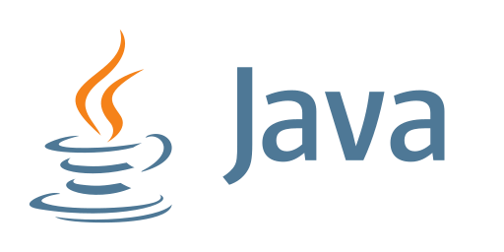

## 6.3. Microsoft Access:

In the Recipe Finder project, a Microsoft Access database is used to store and manage all of the information related to the recipes, including the ingredients, cooking instructions, and other details. Microsoft Access is a popular relational database management system that allows users to create and manage databases with ease. It is known for its user-friendly interface, making it easy for users to create and manage tables, queries, forms, and reports.

In addition to the Microsoft Access database, the project also utilizes the ucanaccess driver API. This API is an open-source Java library that allows for the use of Microsoft Access databases with Java applications. It provides a JDBC driver that allows Java programs to interact with Access databases, enabling the Recipe Finder project to connect to the Microsoft Access database and retrieve the necessary data for the recipe search functionality.

The use of the ucanaccess driver API in the Recipe Finder project allows for seamless integration between the Java programming language and the Microsoft Access database, enabling the application to efficiently retrieve and manipulate data from the database. This allows for a more robust and scalable software solution that can handle a large number of recipes and users.

Overall, the use of Microsoft Access and the ucanaccess driver API in the Recipe Finder project allows for a powerful and efficient solution for managing and searching through a large database of recipes.

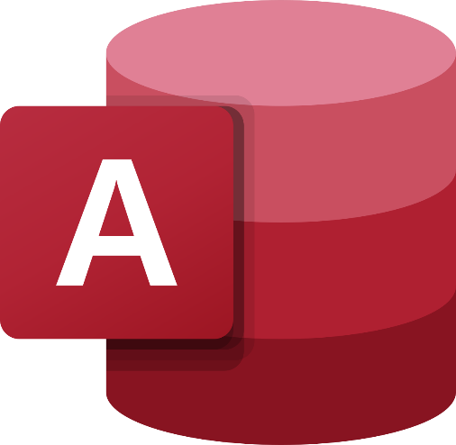

**6.4. Structured Query Language (SQL):**

SQL, or Structured Query Language, is a powerful and widely-used programming language for managing and querying databases. In the case of MS Access, SQL can be used to create, modify, and query the data stored within the database. One way to access MS Access databases using SQL is by utilizing the UCANAccess API, which is an open-source JDBC driver that enables Java programs to interact with MS Access databases.

The UCANAccess API allows developers to use standard SQL commands to perform a variety of tasks within MS Access, such as creating tables, inserting and updating data, and querying the database for specific information. This makes it easy to work with MS Access data in a consistent and efficient manner, regardless of the programming language or development environment being used.

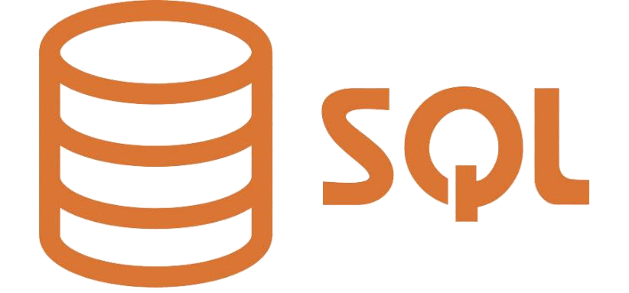

# 7. Flowchart:

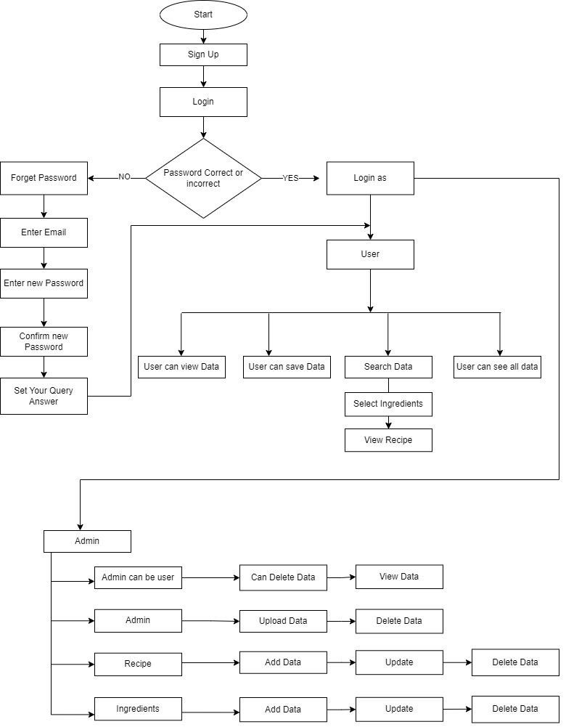

* 1. **. Code:**

Link: https://drive.google.com/file/d/1_1auLd7OaR3_pFod68_3iq2v-cU12vFp/view?usp=share_link

# 8. Application UI:

## 8.1. Login Page:



## 8.2. Signup Page:

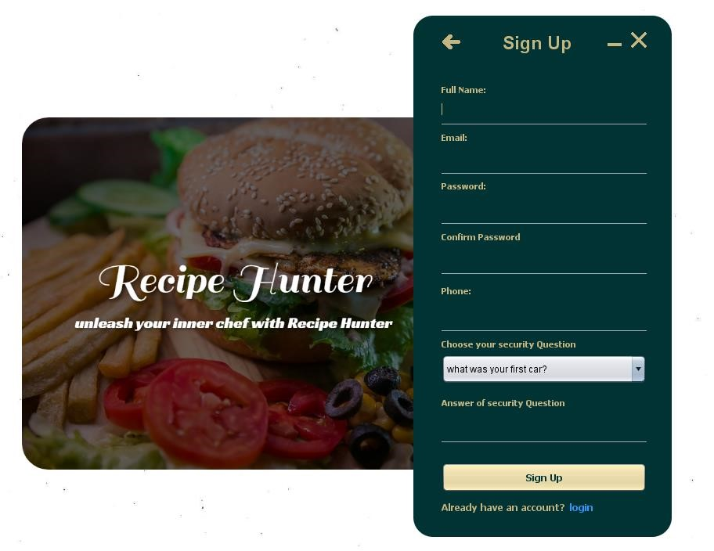

## 8.3. Forgot Password:

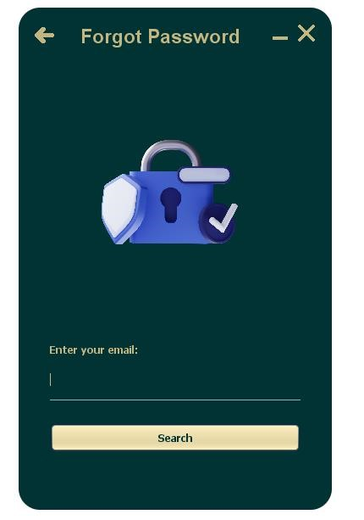

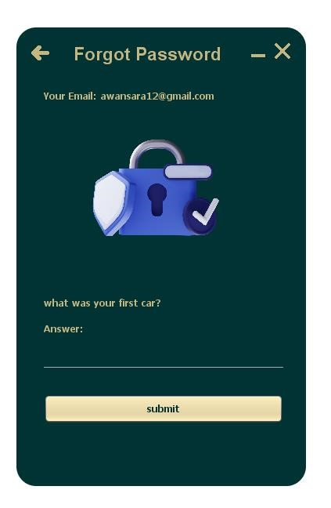

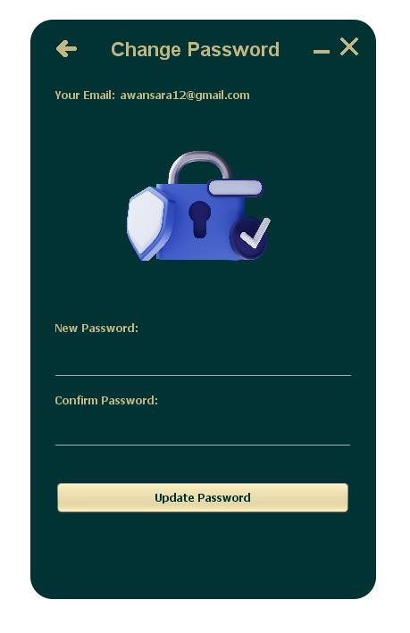

## 8.4. User Section:

## 8.5. User Dashboard:

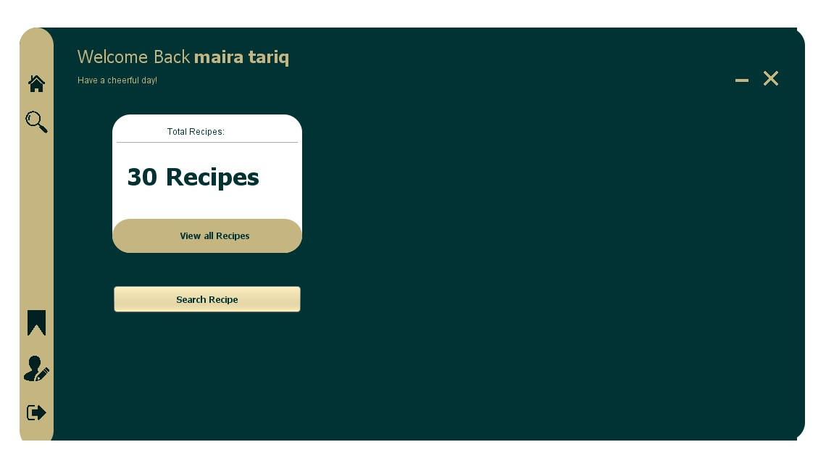

## 8.6. Search Recipe:

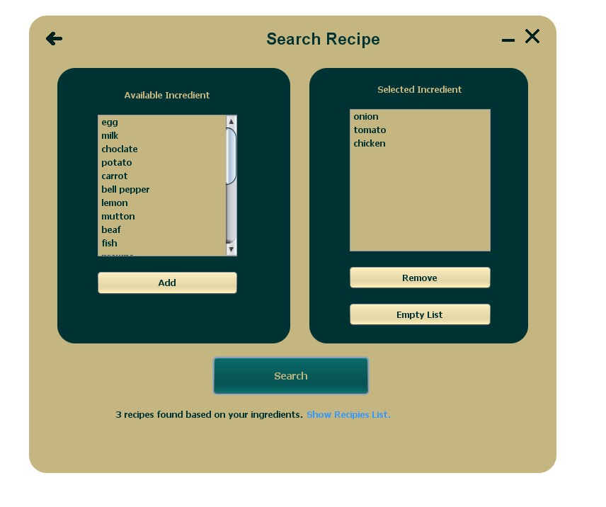

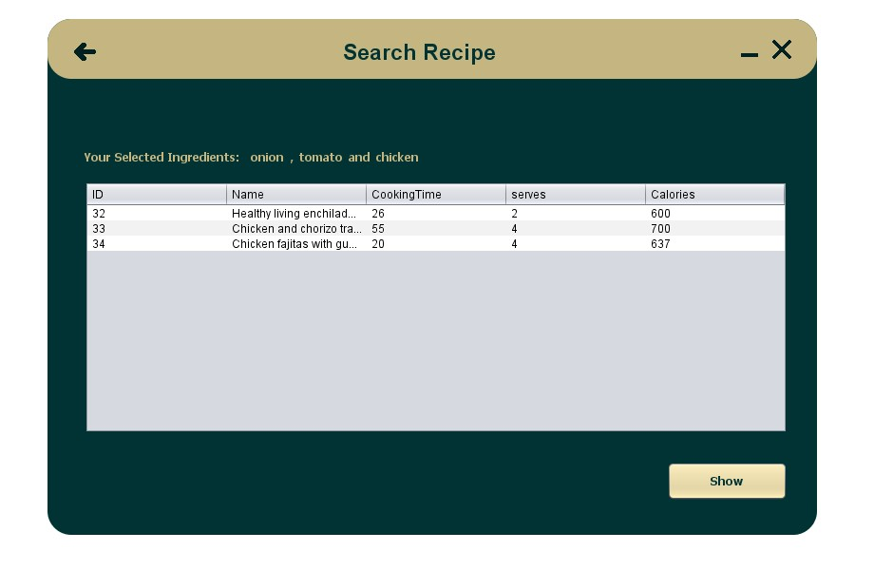

## 8.7. View Recipe Details:

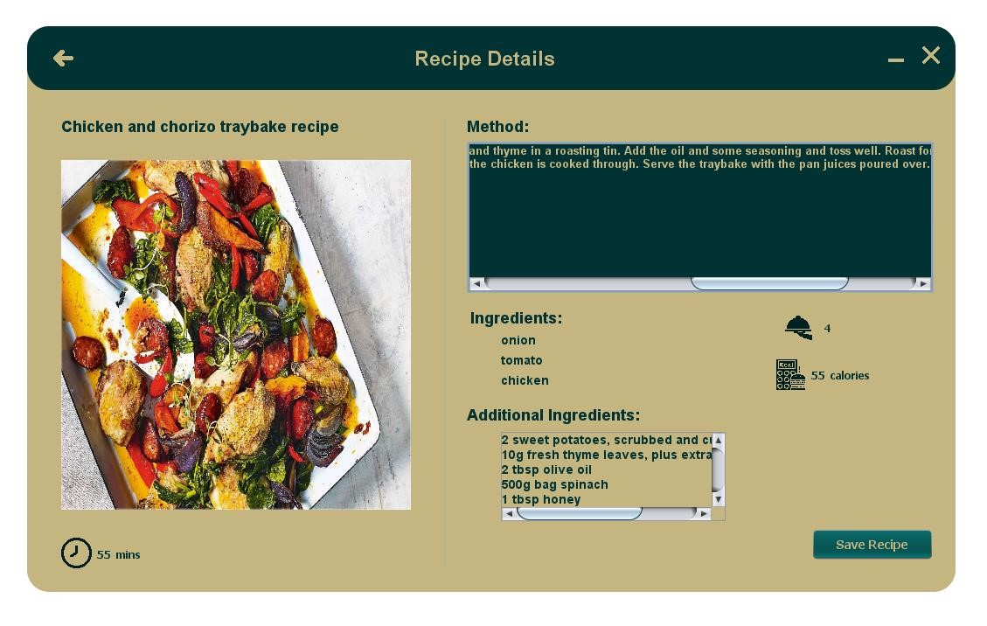

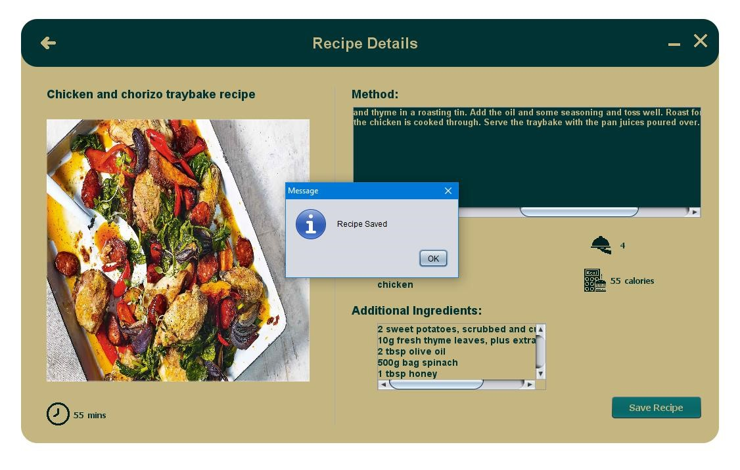

## 8.8. All Recipes:

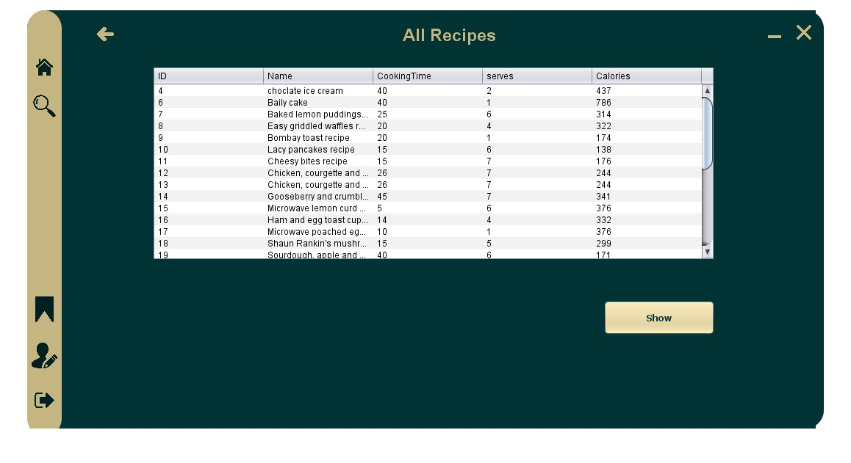

## 8.9. Saved Recipes:

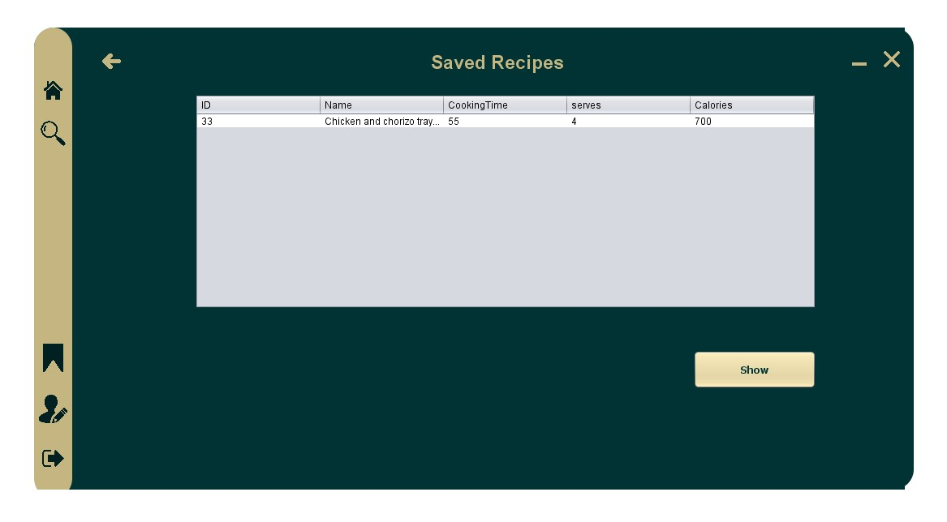

## 8.10. Edit Profile:

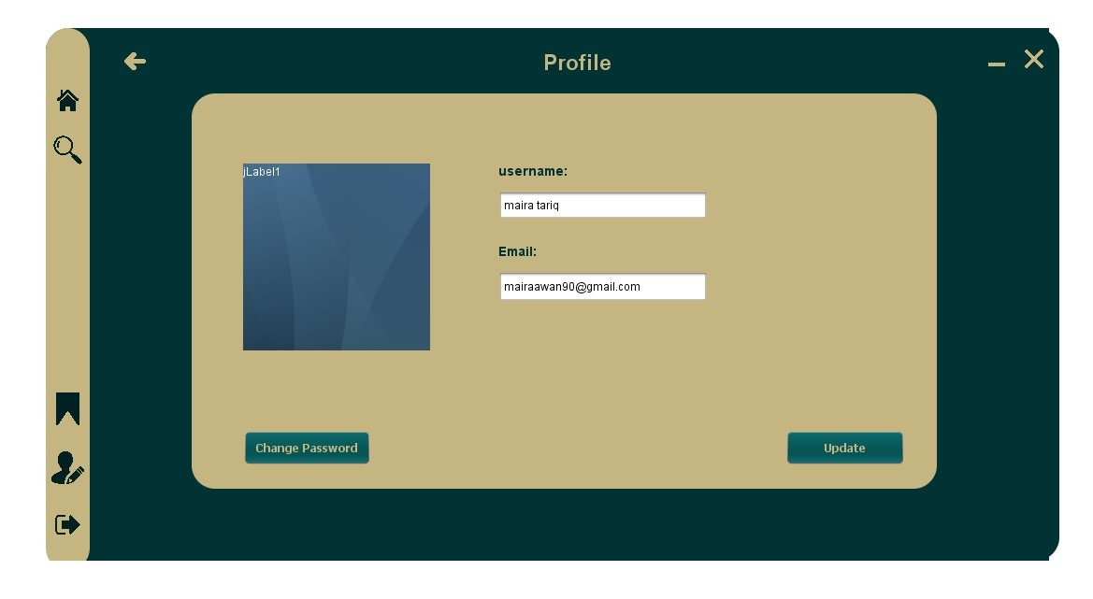

## 8.11. Change Password:

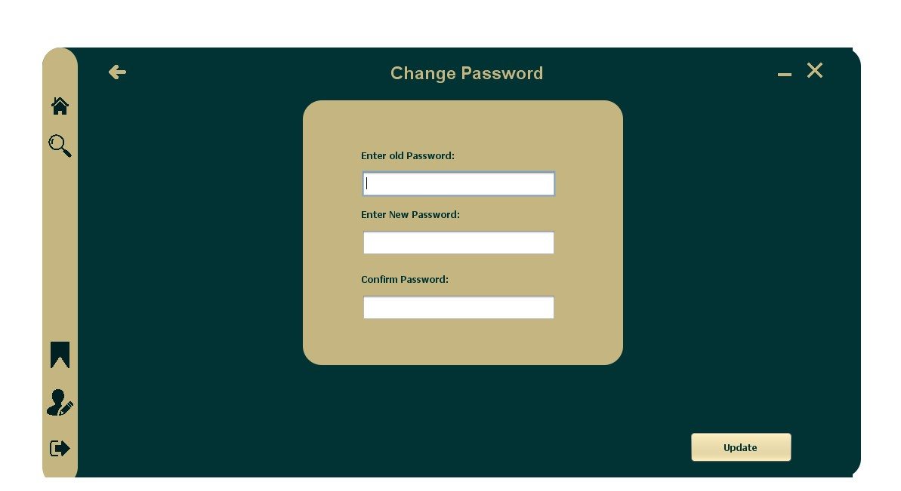

## 8.12. Admin Section:

## 8.13. Admin Dashboard:

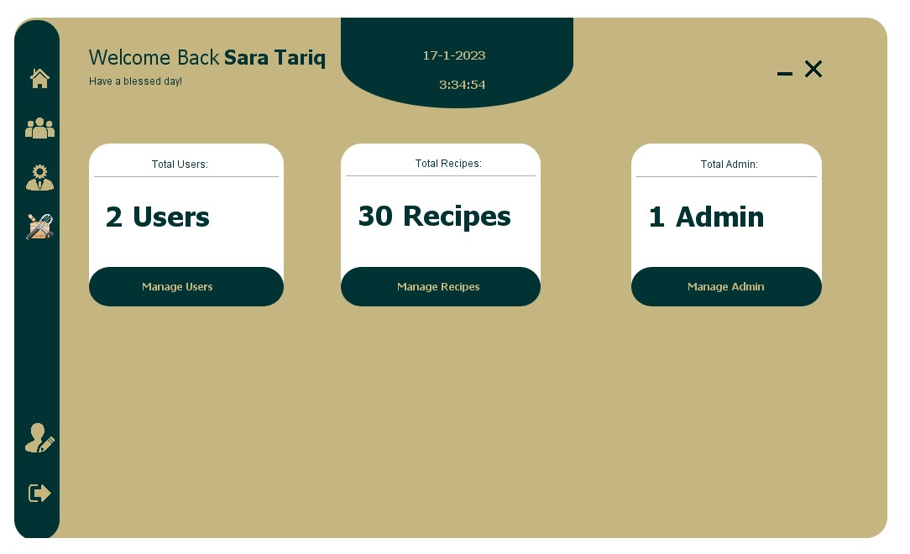

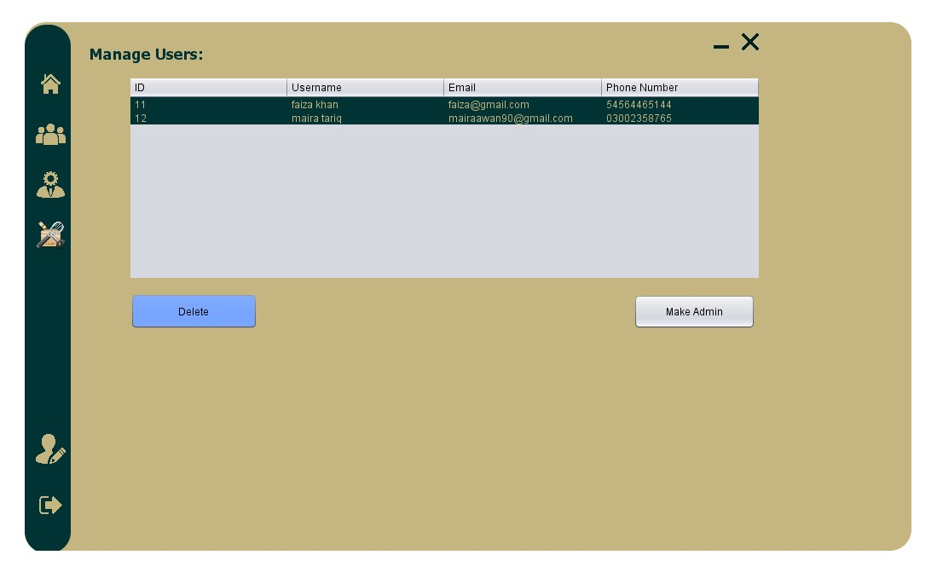

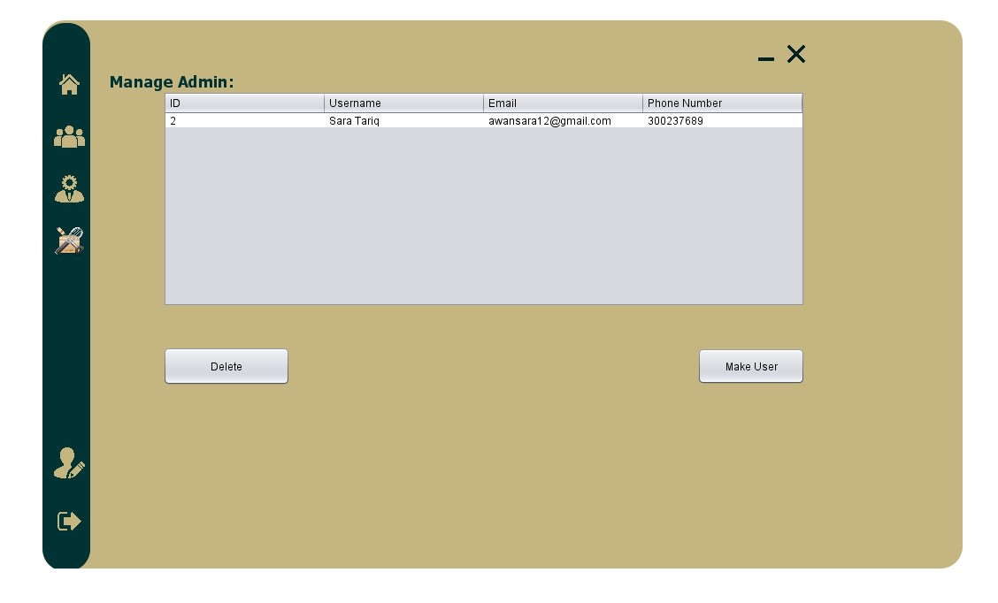

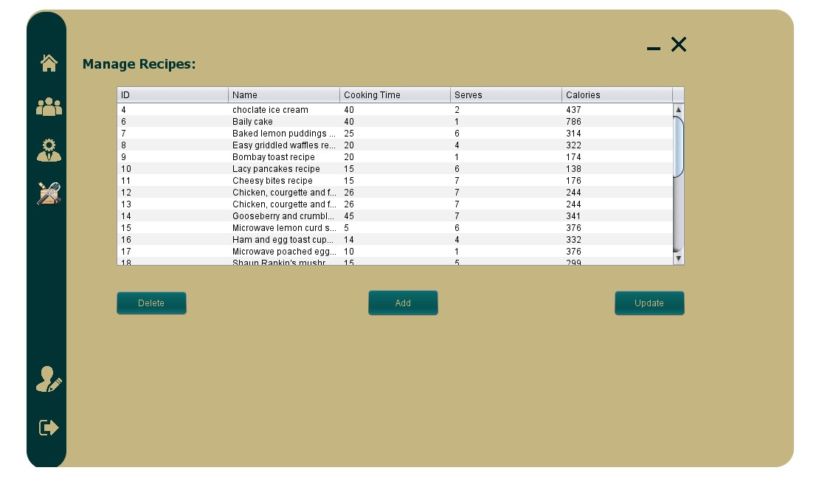

## 8.14. Admin Profile:

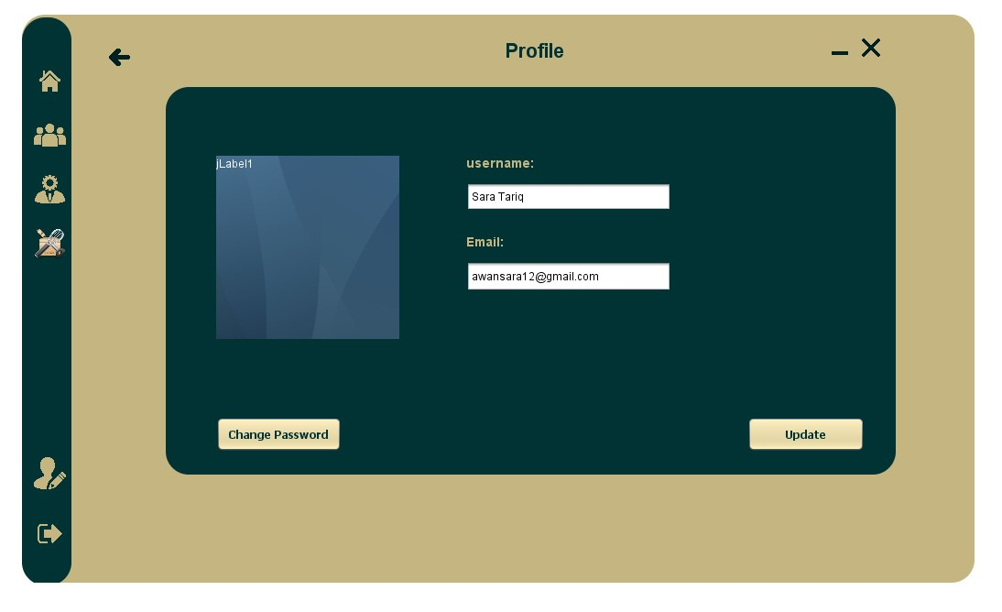

## 8.15. Change Password:

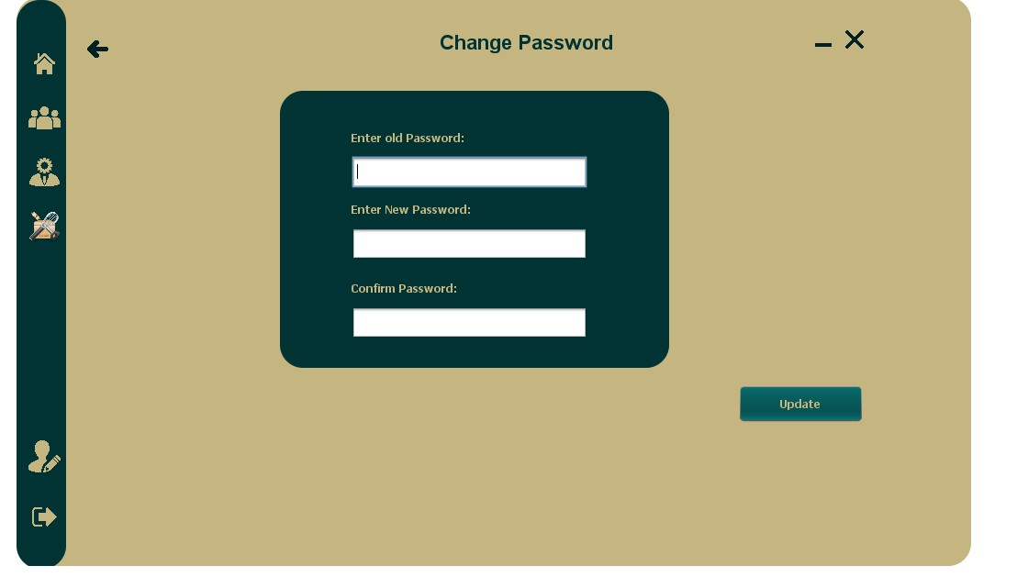

## 8.16. Add Recipe:

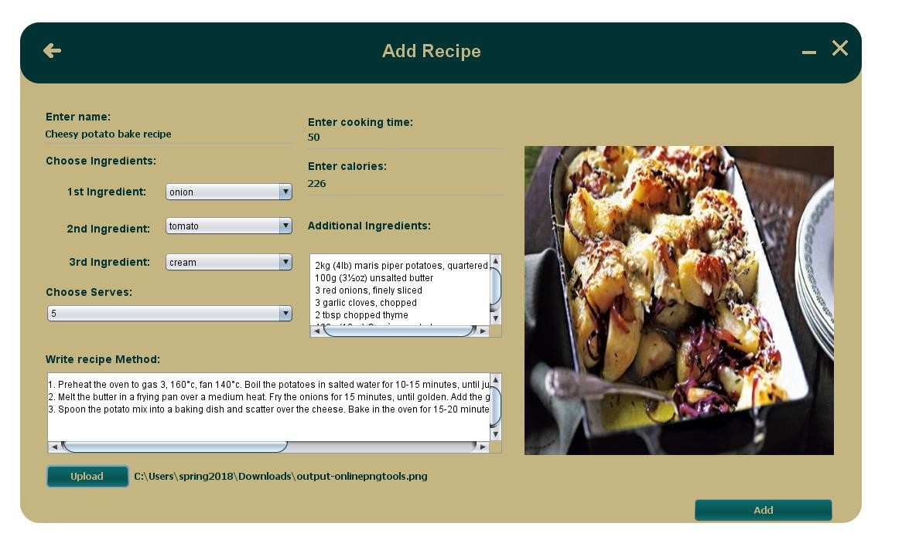

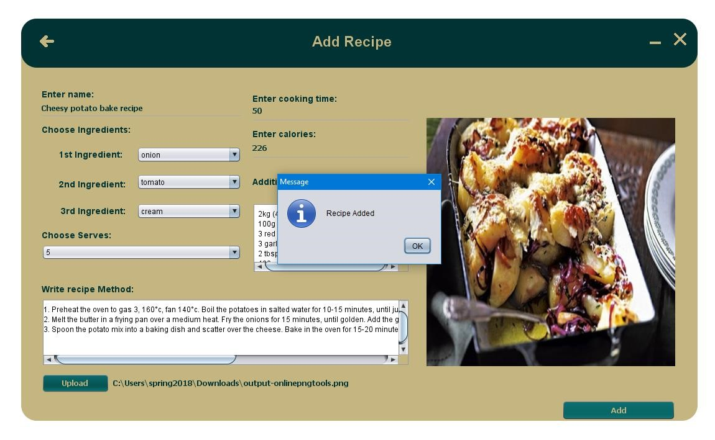

## 8.17. Update Existing Recipe:

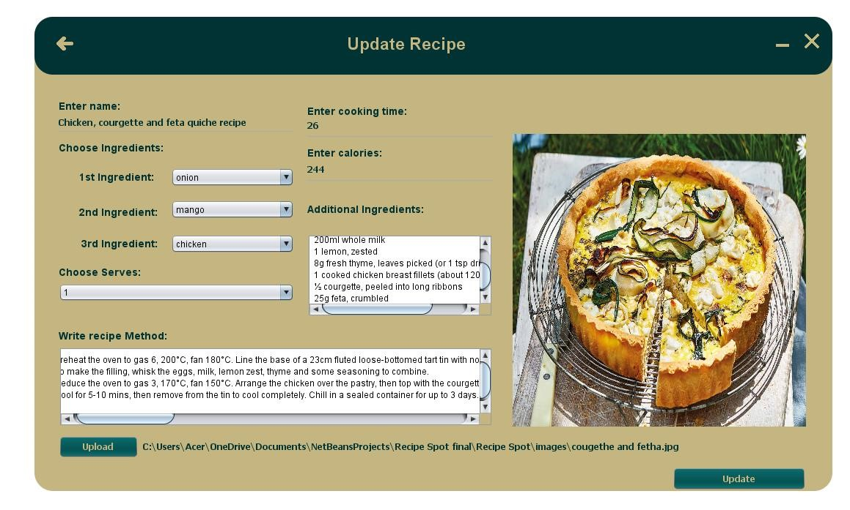

## 8.18. Updating user roles:

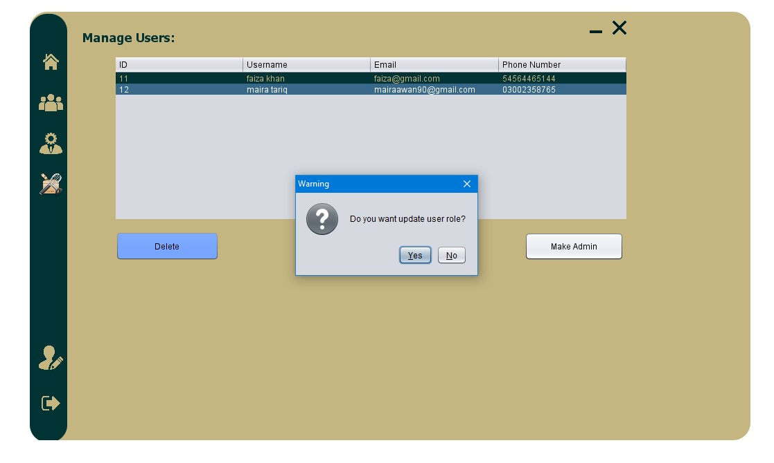

# 9. Conclusion

In conclusion, the Recipe Finder project is a software application that aims to provide users with an easy and convenient way to find recipes based on the ingredients they have on hand. The project is built using the Java programming language and a Microsoft Access database, and utilizes the ucanaccess driver API to connect to the database and retrieve the necessary data.

The software is designed to be user-friendly and easy to navigate, making it accessible to a wide range of users. The main feature of the software is the ability for users to input the ingredients they have available and receive a list of recipes that match those ingredients. Additionally, users can save their favorite recipes and create shopping lists based on the ingredients needed for a particular recipe.

The project also includes functionalities for admin users, such as managing the recipe database and adding new recipes, managing and delete users, and view the total number of users. To ensure the security of user’s information, the project uses SHA 256 encryption to encrypt the users' passwords.

Overall, the Recipe Finder project is a robust and efficient tool that can help users to find and make recipes using the ingredients they have on hand. The project is a great example of how a combination of the Java programming language, Microsoft Access, and the ucanaccess driver API can be used to create a powerful and efficient software solution.